# SUPERSTORE REPORT

**OVERVIEW**

This dataset contains transactional data from a retail business for a period of four years from 2014 to 2017, capturing various aspects of sales performance, customer trends, and product profitability. It includes insights into key metrics such as revenue, profit margins and sales volume across product categories, customer demographics and geographic regions. The report identifies top performing products, regions and customer segments, highlights under performing areas, and suggests strategies for improving overall business performance. Based on the data, the store has its operations in four regions in the United States of America.

Below is a graphical summary of the analysis:

**KEY INSIGHTS**

1. **Revenue Trend**: The total revenue of the store is $2.3 million, with a profit margin of 12.5%. The store had its highest revenue in 2017 with a value of $733,215 while its lowest was in 2015 with a value of $470,532.

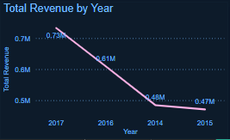

1. **Product analysis:** The product category driving the most profit for the superstore is Technology, with a total profit of $145,454. This also means that the superstore’s highest selling product category is Technology with a value of $836,154.

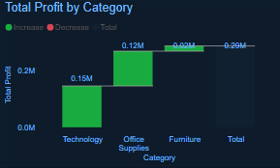

From the chart above, we can see a very high amount of revenue from furniture at $741,999, which is the second highest among the product categories, but a low amount of profit at $18,451, which is the lowest amount of profit. This shows that furniture is the least profitable product category in the store.

1. **Customer Insights:** The store has a total of 793 customers, and they have been categorized into different segments based on the product they purchase from the store. The segments are consumer, corporate, and home office. The most profitable customer segment to the store is the consumer segment with a total profit of $131,119, the corporate segment follows with a total profit of $91,979, while the home office segment comes in third place with a total profit of $60,298.

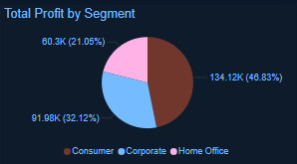

1. **Regional Performance:** The store had activities in four regions, and the region that is most profitable to the store is the West, which had a total profit of $108,418 and total revenue of $725,457. The East region follows with a total profit of $91,522 and total revenue of $678,781. Taking a close look at the South and Central regions, the south has a total profit of $46,749 while the central region has a total profit of $39,706 but a higher amount of revenue ($501,239) than the south region ($391,721). This shows that the central region is the least profitable region to the store.

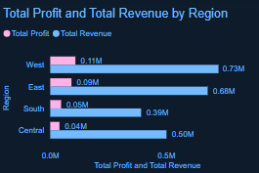

1. **Growth Strategy:** The central region has the highest discount put in place to increase sales, with the total sum of discounts in the region at $558. Although the discount achieved its aim of high sales to an extent, the region remains the least profitable among the other regions as has been previously established.

The East region, having the second highest sum of discounts at $414, benefited from the discounts given and is the second most profitable region to the store and the region with the second highest amount of revenue as established previously.

**METHODOLOGY**

* **Data Sources**: The data was gotten from an online source.
* **Data Preparation**: The dataset underwent cleaning to address inconsistencies. Non-essential features were removed for focused analysis.
* **Tools Used**: Microsoft Power BI was used throughout the process.

**RECOMMENDATIONS**

1. Expenses should be reduced in the central region to increase profitability.
2. In the product category, the store should work towards reducing the cost of obtaining furniture to allow for increased profitability of the product.
3. Another marketing strategy aside from giving discounts needs to be applied to the central region, not just to increase revenue but to increase profitability.

**CONCLUSION**

In summary, the analysis of the Superstore sales data yields important information on consumer behavior, store performance, and operational effectiveness. The main conclusions show that although some product categories and geographical regions generate substantial revenue and profit, there are still opportunities in underperforming segments and areas that call for focused improvement efforts.